To Install

Run the AT.exe file included in the email.

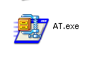
When the WinZip Self-Extractor window appears, make sure to set the “C:\” in the folder text box.

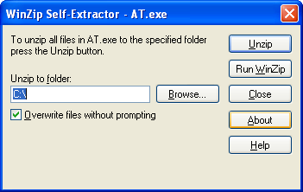

Then press Unzip. The Self-Extractor should return a message like this

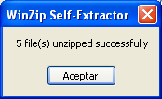

Press the Close button, and open a Windows Explorer session. Go to root path in the C drive and check for the AT directory structure.

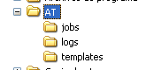

Inside the AT directory you will find the AT_Tester.exe file. This file is a User Interface that will let you test the component in a friendly way.



Directory Structure

In this section I will explain the directory structure of the Admin Tracking solution. Once you decompress the AT file, you will find in the C:\AT drive the following subdirectories

In the jobs subdirectory, will find the XML templates created by the AT_Tester user interface and/or the DLL component. The name convention for the new files is:

J_DIS_<table name>_YYYY_MM_DD_hh_mm_ss_ms.XML

YYYY year
MM month
DD day
hh hour
mm minutes
ss seconds
ms milliseconds

In the logs subdirectory you will find a log file for every XML file created with the user interface and/or the DLL component. In case of an error at the time you are creating a new template, you will find useful information in these files. The naming convention for these files is:

YYYY_MM_DD_hh_mm_ss_ms.LOG

YYYY year
MM month
DD day
hh hour
mm minutes
ss seconds
ms milliseconds

In the templates subdirectory will reside the template file used to create the new XML files.

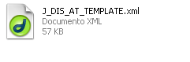

The AT_Tester user interface

The AT_Tester user interface was developed to make easier the test of the Admin Tracking component. It provides a graphic user interface that will let the users configure the connection to their database and the table information that they want to use to create the new XML file.

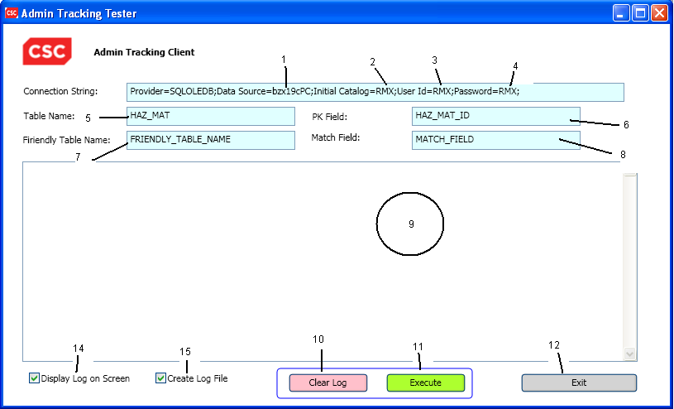

- Database server name.
- Database name
- User to login in the database server
- Password to login in the database server
- Table name use to generate the new XML file
- Primary key use to generate the new XML file
- Friendly table name
- Match field. The field used to match records.
- Log messages area
- Clear Log button. Clears the log message area
- Execute button. Run the components that will generate the new XML file
- Exit button. Close the AT_Tester
14. Check box to display or not the log messages in the log message area
15. Select if you want to create the log file or not.

DLL Component

In this section, I will describe the functions and order of execution of them in order to complete the generation on the new XML file

setRmxTableInfo

Specifies the table information necessary to generates the new XML file

public void setRmxTableInfo(string tableName, string friendlyTableName, string primaryFieldKey, string matchingField)

tableName Name of the table to be use
friendlyTableName Friendly name of the table to be use
primaryFieldKey Primary key of the table
matchingField The component will search for this field

setLogInfo

Set proper vales

public void setLogInfo(bool debugOnConsole, bool debugInLogFile, string logDir)

ATCore objATCore = new ATCore();
objATCore.setRmxTableInfo(txtTablename.Text, txtFriendlyName.Text, txtPKField.Text, txtMatchField.Text);
objATCore.setLogInfo(chkDisplayLogOnScreen.IsChecked.Value, chkCreateLogFile.IsChecked.Value, "c:\\at\\logs");
objATCore.setJobInfo("c:\\at\\jobs","J_DIS");
objATCore.setTemplateInfo("c:\\at\\templates", "J_DIS_AT_TEMPLATE.xml");
objATCore.setRmxDbConfig(txtConnectionString.Text);
bool result = objATCore.generateJob();

public void setRmxTableInfo(string tableName, string friendlyTableName, string primaryFieldKey, string matchingField)

public void setLogInfo(bool debugOnConsole, bool debugInLogFile, string logDir)

public void setJobInfo(string jobDirectory, string jobFileNamePrefix)

public void setTemplateInfo(string templateDirectory, string templateFileName)

public void setRmxDbConfig(string rmxConnection)

public bool generateJob()

